LatCtrl Design Overview

1. 信号输入输出接口

信号输入：

1. 仲裁信号：AsyLatCtrlModReqGroup Record of AS lateral mode request,with checksum and counter form AsyActtnArbnMgr
2. 车身物理数据 DynCalMgr(Incoming CarConfig values are used to selected CarConfig-dependent parameter values(Dynamic Calibration)sent on outports)

|  |  |
| --- | --- |
| DynCalPrmForBicycleMdlAxleDistFrnt | Distance between front axle and centre of gravity |
| DynCalPrmForBicycleMdlCornrgStfnFrntByVehSpd | The vehicle front cornering stiffness |
| DynCalPrmForBicycleMdlCornrgStfnRetByVehSpd | The vehicle rear cornering stiffness |
| DynCalPrmForBicycleMdlJ | Vehicle inertia around z-axis |
| DynCalPrmForVehM | The vehicle weight |
| DynCalPrmForVehWhlBas | The vehicle wheelbase |
| DynCalPrmForVehSteerWhlAgRat | The vehicle steering wheel angle ratio |
| DynCalPrmForVehTyp | The vehicle type |
| DynCalPrmForVehicleSpdForBicycleMdlCornrgStfn | Vehicle speed break points used for finding the cornering stiffness |

1. SnsrFusn(Sensor fusion)

|  |  |
| --- | --- |
| LaneMkr | Observed lane marking in front of vehicle.Estimates are updated to current time. |
| Obstcl | Observed barriers in front of vehicle.Estimates are update to current time. |
| RoadEdge | Observed road edge in front of vehicle.Estimates are update to current time. |
| VehSelf | Ego Vehicle |

1. AutDrvCtrl(Automated Drive Control)—ACC TJA CSA SLA

|  |  |
| --- | --- |
| PahDataFromTrfcJamAssi | Describing the snail-trail of the snail-trail of the target vehicle.It is a spline with 30 control points in the vehicle xy-frame |

1. CllsnRednByBrkgCtrl(Collision Reduction By Braking Controller)

|  |  |
| --- | --- |
| PinionSteerAgReq | Requested pinion angle by CMbB(Steering Assistance) |

1. LaneKeepAidCtrl

|  |  |
| --- | --- |
| SteerDataFromLaneKeepAid | This is the steering path data structure provided by lanekeepaidCtrl |

|  |  |
| --- | --- |
| SteerTqReqScaCoeff | Scaling factor of requested steering torque due to the driver override |

|  |  |
| --- | --- |
| Vehv | Record of lateral and longitudinal vehicle velocity |
| SteerWhlTqLimActvd | Indicates whether the requested overlay torque has been limited or not by the ActiveSafetysteering TorqueManager（Both level and rate limitations） |

Signal Extraction

1）根据CtrlRef判断选取的是LaneMkr、RoadEdge、还是Obstcl的数据---LKAReferencePolynom

2）根据ITC格式输出LKAPathData数据

3）提取SplineX和SplineY、ValidSample点提取TJAPathData数据

4）提取车身数据YawRate、VLgt—Vehicle Speed

5）提取DILFactor参数

6）提取SteerTorqueTqLimActvd 提取是否TorqueLimitActivation

7) 车身物理数据的直接传递

LatCtrl Model

1、Lateral Control Para meters

输出 Output LateralControlParameters and BicycleModelParameters

其中LateralControlParameters参数表中包括了速度阈值、加速度阈值、扭矩阈值

1. Compute Control Metrics

Signal input and output

|  |  |
| --- | --- |
| Input signal | describe |
| LateralControlModeRequest |  |
| LKAPathData | Path information |
| LKAReferencePolynom | Lane or road edge polynom |
| TJAPathData | Traffic Jam assist data |
| VehicleSpeed | Ego vehicle |
| LateralControlParameters | Control parameters |
| BicycleModelParameters | Model parameters |
| PinionAngle | Last pinion angle |
| DILFactor | Scaling factor of requested steering torque due to the driver override |
| TorqueLimitActivation | Determine Boolean for the torque is greater than the threshold |
| YawRate | Gyroscale value |
| VlatError | lateral velocity error |
| LatCtrlTestBus | ? |

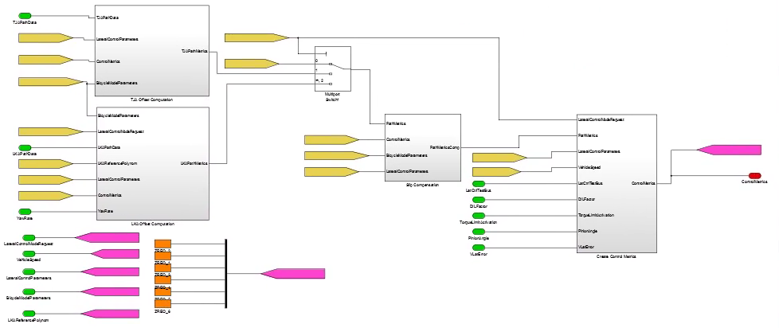

在该模块中，共有四个blocks，分别为：TJA Offset Computation、LKA Offset Computation、Slip Compensation 和Create Control Metrics

1. TJA Offset Computation
2. LKA Offset Computation

|  |  |
| --- | --- |
| Input signal | describe |
| BicycleModelParameters | Bicycle model parameters |
| LateralControlModeRequest | Lateral control mode（intervention） |
| LKAPathData | LKA Path data |
| LKAReferencePolynom | Lane marking polynom |
| LateralControlParameters | Ego vehiclecontrol parameters |
| ControlMetrics | Control parameters |
| YawRate | Gyroscale value |

1. LatCtrlCalcPathEvaluationMetrics

|  |  |
| --- | --- |
| Input signal | describe |
| ValidRange | Road valid range |
| VehicleSpeed | Vehicle speed |
| VehicleSpeedLimited | Low speed limit High |
| LookAheadNominalTime | Nominal time |
| LookAheadMinimum | Minimum |
| LowrSpdLimforPathExtrap | 0 |

|  |  |
| --- | --- |
| output signal | describe |
| LookaheadEffectiveTime | Effective time |
| LookaheadEffectiveDistance | Effective distance |

有效时间和距离的计算公式如下

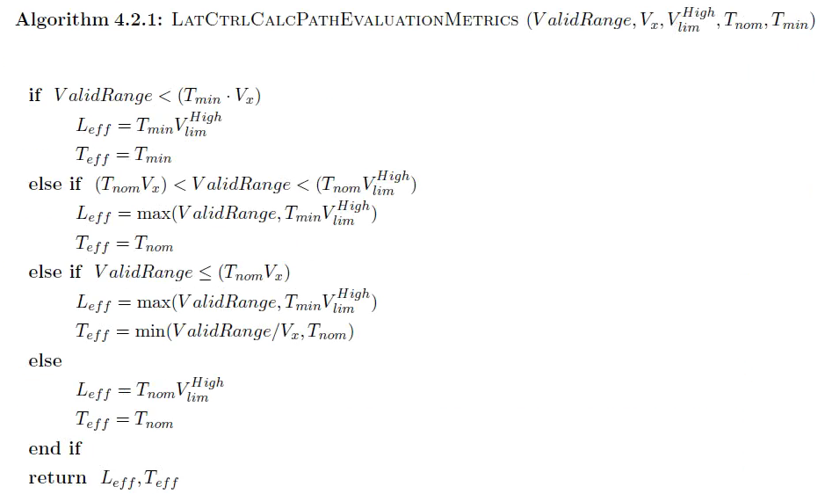

1. LKA Calculate Road Offset

|  |  |
| --- | --- |
| Input signal | describe |
| LateralControlParameters | Thresholds tunning parameter |
| WheelBase |  |
| LKAPathData |  |
| LKAReferencePolynom |  |
| VehicleSpeed |  |
| YawRate |  |
| LookaheadEffectiveDistance |  |

|  |  |
| --- | --- |
| output signal | describe |
| LKALocalRoadOffset |  |
| LKALookAheadRoadOffset |  |
| LKALocalRoadHeading |  |
| ValidRoadRange |  |

该模块主要是计算车到车道线的距离、车与车道线的夹角以及预瞄点到车道线的距离

在该模块中，当选择的车道线稳定是，需要进行车道线的滤波、稳定车道线的拟合参数

模块为LKA lane filter

计算输出LKALocalRoadOffset、LKALookAheadRoadOffset、LKALocalRoadHeading、ValidRoadRange

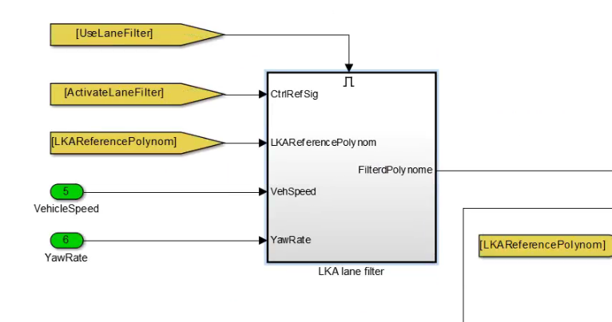

LatCtrl TestBus

|  |  |  |
| --- | --- | --- |
| OpenLoopMode | 0 | OpenLoopMode(0) |
| VlatRequest | 0 | 0 |
| YawRateClosedLoopRequest | 0 | 0 |
| PinionAngleClosedLoopRequest | 0 | PinionAngleClosedLoopRequest |
| LocalOffsetDisturbance | 0 | LocalOffsetDisturbance |
| ResetForTest | 0 | 0 |

1. LKA Calculate Path Offsets

|  |  |
| --- | --- |
| input signal | describe |
| LookaheadEffectiveTime |  |
| LKAPathData |  |
| VehSpdLgt |  |
| LateralControlModeRequest |  |
| LocalOffsetEffectiveTime |  |

|  |  |
| --- | --- |
| output signal | describe |
| LKALocalPathOffset |  |
| LKALookAheadPathOffset |  |
| LKALocalPathHeading |  |

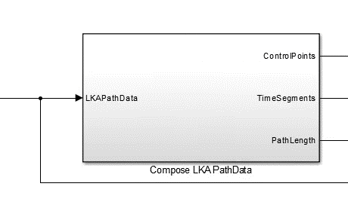

|  |  |  |  |
| --- | --- | --- | --- |
| Input Signals | describe | Output Signals | describe |
| LKA PathData |  | ControlPoints | 每段侧向加速度 |
|  |  | TimeSegments | 每段的时间 |
|  |  | PathLength | 时间总和 |

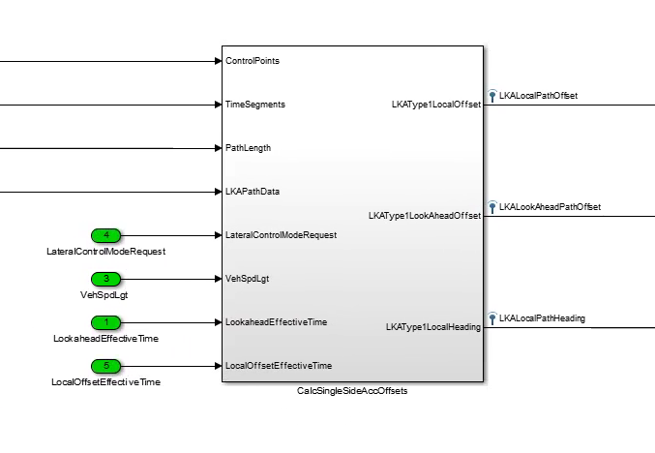

|  |  |  |  |
| --- | --- | --- | --- |
| Input Signals | describe | Output Signals | describe |
| ControlPoints |  | LKAType1LocalOffset | 车到轨迹线的距离 |
| TimeSegments |  | LKAType1LookAheadOffset | 预瞄点到轨迹线的距离 |
| PathLength |  | LKATypeLocalHeading | 车与轨迹线的夹角 |
| lateralControlModeRequest |  |  |  |
| VehSpdLgt |  |  |  |
| LookaheadEffectiveTime |  |  |  |
| LocalOffsetEffectiveTime |  |  |  |

模块中通过初始速度和位置，每一段的加速度计值和每一段的时间，积分速度，叠加到位置信息

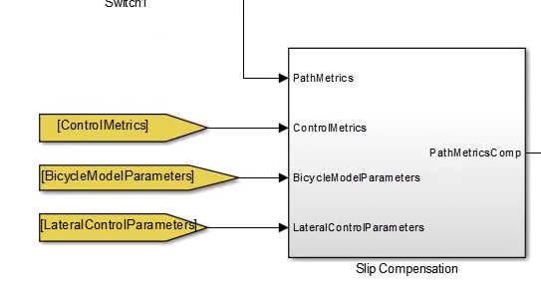

补偿侧偏角

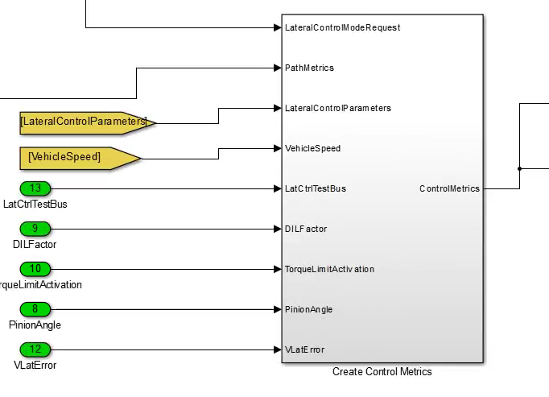

配置控制器参数

|  |  |  |  |
| --- | --- | --- | --- |
| Input Signals | describe | Output Signals | describe |
| LateralControlModeRequest |  | ControlMetrics | 控制参数列表 |
| PathMetrics |  |  |  |
| LateralControlParameters |  |  |  |
| VehicleSpeed |  |  |  |
| LatCtrlTestBus |  |  |  |
| DILFactor |  |  |  |
| TorqueLimitActivation |  |  |  |
| PinionAngle |  |  |  |
| VlatError |  |  |  |

1）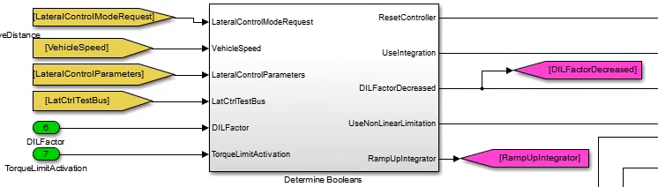

|  |  |  |  |
| --- | --- | --- | --- |
| Input Signals | describe | Output Signals | describe |
| LateralControlModeRequest |  | ResetController | 复位（1） |
| VehicleSpeed |  | UseIntegration | 0 |
| LateralControlParameters |  | DILFactorDecreased | 扭杠大（0）扭杠小（1） |
| LatCtrlTestBus |  | UseNonLinearLimitation | mode稳定True |
| DILFactor |  | RampUpIntegrator | 扭杠接入（1）如果不介入（0） |
| TorqueLimitActivation |  |  |  |

1. Conparator w hystersis

13.6

10

2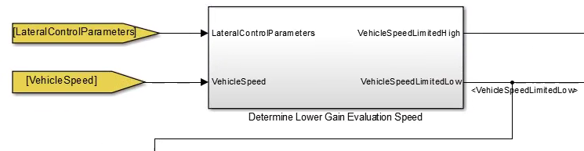

|  |  |  |  |
| --- | --- | --- | --- |
| Input Signals | describe | Output Signals | describe |
| LateralControlParameters |  | VehicleSpeedLimitedHigh | 输出汽车速度 |
| VehicleSpeed |  | VehicleSpeedLimitedLow | 下限值6m/s上下0.1做平滑 |

3

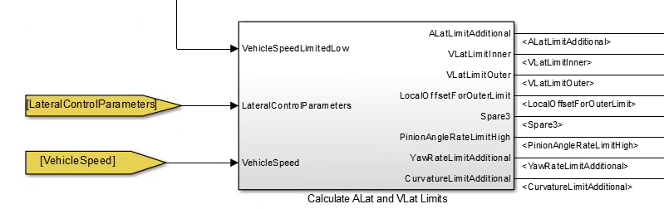

|  |  |  |  |
| --- | --- | --- | --- |
| Input Signals | describe | Output Signals | describe |
| VehicleSpeedLimitedLow |  | ALatLimitAdditional | 查表侧向加速度的阈值 |
| lateralControlParameters |  | VlatLimitIneer | 查表侧向侧速度的阈值 |
| VehicleSpeed |  | VlatLimitOuter | 查表侧外侧速度的阈值 |
|  |  | LocalOffsetForOuterLimit | 外侧offset阈值1.5m |
|  |  | Spare3 | 0 |
|  |  | PinionAngleRateLimitHigh | 查表Pinionangle变化速率 |
|  |  | YawRateLimitAdditional | 查表向心力作用下yawrate变化率限制 |
|  |  | CurvatureLimitAdditional | 查表心力作用下曲率变化率限制 |

4

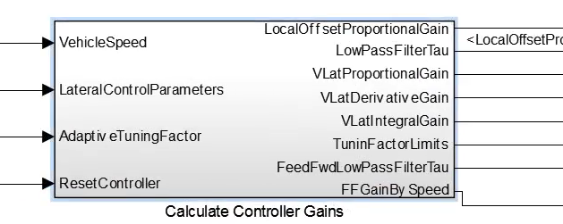

|  |  |  |  |
| --- | --- | --- | --- |
| Input Signals | describe | Output Signals | describe |
| VehicleSpeed |  | LocalOffsettProportionalGain |  |
| lateralControlParameters |  | LowPassFilterTau |  |
| AdaptiveTuningFactor |  | VLatProportionalGain |  |
| ResetController |  | VLatDerivativeGain |  |
|  |  | TuninFactorLimits |  |
|  |  | FeedFwdLowPassFIlterTau |  |
|  |  | FFGainBySpeed | 查表增益（1） |

5